**CHAPTER 1**

**INTRODUCTION**

**1. 1 OVERVIEW OF THE PROJECT**

It is generally accepted now that the Internet and online games provide a tremendous opportunity for new forms of entertainment and for growing the game market at large. With the massive success of online games, ranging from games such as Face book to online gaming and Shockwave, it's pretty clear that this opportunity is real and here to stay.

Online features are now starting to take hold in the console wars. It's no longer a question of whether the console world will embrace online, but how much. For the independent developer, the online world offers opportunities ranging from contrarian business models, to a less risky way to try out new ideas, to simply a way to work on different and cool

This Game emphasis on Activity based learning. As the recent research suggest that Activity based learning helps the students to improve their knowledge and learn faster. The Game Features with Google Map embedded in gaming scenario. It enables the gamer to fascinate about locating all the places around the world, thus enrich Geographical knowledge of the gamer and also factual information about the specified places. To keep the Gamers interested and to boost the skills of the gamer, time limits and score are bought into the picture. Frequent updating feature will allow the gamer to keep involved every time around and chance for learning about various places.

**1. 2 EXISTING SYSTEM**

The Existing system is entirely gaming oriented and remains just as an entertainment tool. It is regarded as a worthless time gaming application and waste precious time of the user. It is 2D- arcade game, called “puzzle treasure hunt”.

**Puzzle Treasure Hunt**

A puzzle treasure hunt can be played with groups of children; each group is made up of 4-5 kids. Each group receives a printed page, containing the first puzzle. When they solve the first puzzle, the hiding location of the next clue is revealed to them, and then they run to find the next page. The next page will include a different type of puzzle for which the solution will lead to the hiding location of the 3rd puzzle and so on. When the kids have solved all 6 puzzles they arrive at the hiding location of the treasure. They find the treasure, along with a greeting page congratulating them for finding the treasure

**1. 3 PROPOSED SYSTEM**

The Proposed system offer Activity based learning embedded within the gaming scenario. The game facilitates to understand about various geographical locations and promote visual way to track the map. Thus help students and Knowledge gainer a chance to improve their knowledge about various landscapes, monuments, and civilized places around the globe.

**ADVANTAGES**

* Enhance the Geographical location knowledge of the Gamer.
* It helps to know about factual information about a place.
* It promotes visual way of tracking geo-map location.
* It’s concentrate on both knowledge enhancing as well as generic gaming entertainment tool.

**1. 4 FEASIBILITY STUDIES**

A feasibility study is a study made to decide whether or not the proposed system is worthwhile.

**Technical Feasibility**

The technical feasibility is the study of configuration of the system. While studying the system configuration following things are to be studied,

* What is the exact configuration of the system?
* How many workstations are required?
* How different units are interconnected?
* What should be the speed at which the input is given and at what speed the output has to be generated?

Using this study the tender document can be prepared. Then the manufacturer or dealer can provide the equipments based on desired logical needs. It is necessary to examine more than one configuration with the same key technical aspects so that the choice of better one is made. The technical feasibility study is supposed to be most important and difficult study.

**Operational Feasibility**

The operational feasibility is based on the human factors and political aspects. It can be performed by answering following questions,

* What change will be brought with the system?
* What are the factors that are disturbing organizational structure?
* Which are the new skills that are required for the improvements in operation?

The operational infeasibility does not lead to rejection of the project. The operational feasibility study is made by small group of people who are involved in the project analysis and design activity.

**Economic Feasibility**

This kind of feasibility study is done for the cost or benefit analysis. In this study of benefits of the proposed system are identified and the corresponding costs are determined.

**Management Feasibility**

The management feasibility means checking whether the management will accept the proposed project or not. If top level management does not agree upon the project idea then it is considered as a non feasible project.

**Legal Feasibility**

The legal feasibility means finding out whether the proposed project is legally acceptable or not.

**Time Feasibility**

The time feasibility means identifying whether the proposed project will be completed within the stipulated time or not. If the projects runs for a long time then it is considered to be infeasible project.

**Social Feasibility**

Whether the project will be accepted by the people or not is called a social feasibility.

**1. 5 REQUIREMENT SPECIFICATION**

The requirements specification is a technical specification of requirements for the software products. It is the first step in the requirements analysis process it lists the requirements of a particular software system including functional, performance and security requirements. The requirements also provide usage scenarios from a user, an operational and an administrative perspective. The purpose of software requirements specification is to provide a detailed overview of the software project, its parameters and goals. This describes the project target audience and its user interface, hardware and software requirements.

**3.2 HARDWARE AND SOFTWARE SPECIFICATION**

**HARDWARE USED**

* Processor :Intel Pentium IV and above
* RAM :512 MB of RAM
* Hard Disk :40GB of hard disk space
* Modem : 2-3 Mbps.

**SOFTWARE USED**

* Operating System :Windows XP/7
* Design Language : ASP.NET
* Coding Language : VB.NET
* Database : MS ACCESS 2007
* Scripting Language : JavaScript, JQuery1.8.

**CHAPTER 2**

**DESIGN**

**2.1 OVERALL SYSTEM DESIGN**

**2.1.1 ARCHITECTURE DIAGRAM**

The Architecture explains the process involved in the system. The architecture of the project consists of three core end.

1. Front End.
2. Middle-ware.
3. Back End.

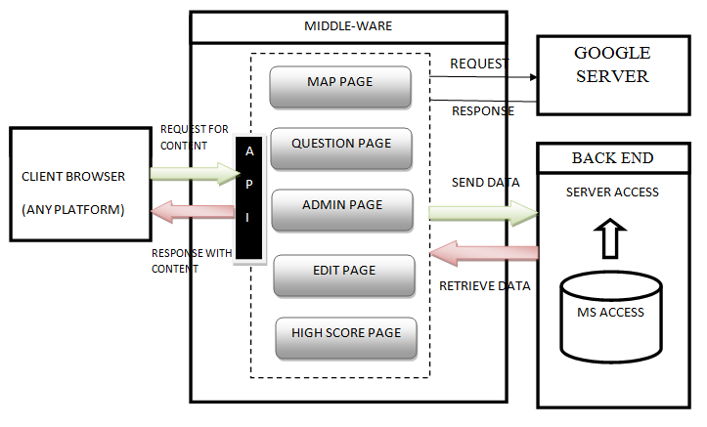

Fig 2.1 SYSTEM ARCHITECTURE

**BACK END**

The Back end consist of the MS ACCESS database in which the

Data are send and retrieve from the database. The database transactions are carried out with the help of SQL Query.

**MIDDLE-WARE**

The middle-ware is the core-part of the architecture encompasses of API and interaction among the webpage. The webpage request for the data from the back end and it is displayed in the specified webpage.

**FRONT END**

The Front end comprises of the client browser where the client request for the content based retrieval from the API.

**2.1.2 LOGICAL DATABASE DESIGN**

**QUESTION TABLE DESIGN**

|  |  |  |
| --- | --- | --- |
| **FIELD NAME** | **DATATYPE** | **SIZE** |
| ID | NUMBER | 5 |
| PLACE | TEXT | 30 |
| CLUE | MEMO | UNLIMITED |
| HINT 1 | MEMO | UNLIMITED |
| HINT 2 | MEMO | UNLIMITED |
| HINT 3 | MEMO | UNLIMITED |
| ZOOM LEVEL | NUMBER | 2 |
| LATITUDE | NUMBER | 9 |
| LONGITUDE | NUMBER | 9 |

**Description:** This table specify the design view of the question table for various levels such continents, countries, capitals, cities, monuments.

TABLE 2.1 QUESTION TABLE DESIGN

**HIGH SCORE TABLE DESIGN**

**Description:** This table specify the design view of the high score table where user is prompt to enter his/her name.

|  |  |  |
| --- | --- | --- |
| **FIELD NAME** | **DATATYPE** | **SIZE** |
| USER NAME | TEXT | 32 |
| SCORE | NUMBER | 8 |
| TOPIC | TEXT | 12 |

TABLE 2.2 QUESTION TABLE DESIGN

**2.1.3 E-R DIAGRAM**

**E-R DIAGRAM OF ADMIN MODE**

LOGIN

ADMIN

EDIT

FIG 2.2 E-R DIAGRAM OF ADMIN MODE

**E-R DIAGRAM OF GAMER**

GAMER

QUESTION

MAP

SCORE

FIG 2.3 E-R DIAGRAM OF GAMER

**2.1.4 DATAFLOW DIAGRAM**

A data flow diagram is graphical tool used to describe and analyze movement of data through a system. These are the central tool and the basis from which the other components are developed. The transformation of data from input to output may be described logically and independently of physical components associated with the system. These are known as the logical data flow diagrams.

The development of DFD’s is done in several levels. Each process in lower level diagrams can be broken down into a more detailed DFD in the next level. The top-level diagram is often called context diagram. It consists of a single process bit, which plays vital role in studying the current system. The process in the context level diagram is exploded into other process at the first level DFD.

**LOGIN DATAFLOW DIAGRAM**

DATABASE

ADMIN

HOME PAGE

CONNECT TO HOME PAGE

FIG 2.4 LOGIN DATAFLOW DIAGRAM

The idea behind the explosion of a process into more process is that understanding at one level of detail is exploded into greater detail at the next level. This is done until further explosion is necessary and an adequate amount of detail is described for analyst to understand the process. Larry Constantine first developed the DFD as a way of expressing system requirements in a graphical from, this lead to the modular design.

A DFD also known as a “bubble Chart” has the purpose of clarifying system requirements and identifying major transformations that will become programs in system design. So it is the starting point of the design to the lowest level of detail. A DFD consists of a series of bubbles joined by data flows in the system.

**ADMIN-ADD, UPDATE, VIEW OTHER USERS DETAILS**

DATABASE

ENTER QUESTION DATA

ADD

UPDATE

ADMIN

DELETE

COMMIT

FIG 2.5 ADMIN-ADD, UPDATE, VIEW OTHER USERS DETAILS

**2.2 DETAILED DESIGN**

**2.2.1 UML DIAGRAMS**

The Unified Modeling Language (UML) is the industry-standard modeling language used for specifying, visualizing, constructing and documenting the artifacts of a software system. The UML is also effective for modeling business and other Non-software systems.

One of the major goals of UML is to present a common modeling language that all developers can use. It is a language whose vocabulary and rules focus on the conceptual and physical representation of the system.

The UML uses Diagram to represent different views of the system being modeled. The purpose of diagram is to present a set of modeled elements, which are rendered as shapes and connectors.

The UML defines nine graphical diagrams:

1. Class Diagram

2. Object Diagram

3. Use-Case Diagram

4. Sequence Diagram

5. Collaboration Diagram

6. State-chart Diagram

7. Activity Diagram

8. Component Diagram

9. Deployment Diagram

**USE CASE DIAGRAMS**

A use case is a description of a set of sequences of actions, including variants that a system performs to yield an observable result of value to an actor. A use case involves the interaction of actors and the system Actors (admin) can be human are they can be automated systems.

**USE CASE DIAGRAM OF ADMIN**



Fig 2.6 Use Case Diagram of Admin

Fig 2.6 represents the use case diagram of admin. In which the administrator can perform modification or updation process on the question table.

**USE CASE DIAGRAM OF GAMER**



Fig 2.7 Use Case Diagram of Gamer

Fig 2.7 represents the use case diagram of gamer. In which the gamer can actively enter into gaming environment and start hunting. Basically it is the list of interaction mode between the gamer and web pages.

**CLASS DIAGRAM**

Class diagrams are the most common diagrams found in modelling object-oriented systems. A class diagram shows a set of classes, interfaces, and collaborations and their relationships. 

Fig 2.8 Class Diagram

Fig 2.8 represents the class diagram. This diagram depicts the individual class and interaction among various classes. It also represents the attribute and methods to be implemented in each class.

**ACTIVITY DIAGRAM**

Activity diagram represents the performance of operations and transitions are triggered by completion of operations.



Fig 2.9 Activity Diagram

Fig 2.9 represents the activity diagram. In which the sequence of activity to be carried out by the gamer during the gaming activity.

**COMPONENT DIAGRAM**

Component diagrams model the physical components like source code, executable program user interface in a design.



Fig 2.10 Component Diagram**.**

Fig 2.10 represents the component diagram. In this diagram dedicates the physical components of gaming activity. The central core physical component lies in the Google map page.

**SEQUENCE DIAGRAM**

An interaction diagram shows an interaction, consisting of a set of objects and their relationships, including the messages that may be dispatched among them. A sequence diagram is an interaction diagram that emphasizes the time ordering of messages. 

Fig 2.11 Sequence Diagram

Fig 5.8 represents sequence diagram. In this diagram the interaction and interaction message between the different classes and objects. The request and response message are indicated by the arrow between the classes.

**STATE-CHART DIAGRAM**

A state chart diagram includes a sequence of states that an object goes through its life in response to outside stimuli message.



Fig 2.12 State-Chart Diagram

Fig 2.12 represents the stat-chart diagram. In this diagram each rectangular box represents the various possible states and flow of data among the states. It also depicts the start and end states during the entire gaming activity.

**COLLABORATION DIAGRAM**

A collaboration diagram is an interaction diagram that emphasizes the structural organization of the objects that send and receive messages. Graphically, a collaboration diagram is a collection of vertices and arcs.



Fig 2.13 Collaboration Diagram

Fig 2.13 represents the collaboration diagram. This diagram depicts the interaction among the class and the information passed between the classes. The arrow and data suggest the information to pass among the classes.

**CHAPTER 3**

**IMPLEMENTATION AND TESTING**

**MODULES**

* **Administrator Module**
* **Roam Module**
* **Hunt Module**
* **Status Module**

**MODULE EXPLANATION**

**3.1 ADMINISTRATOR MODULE**

This module allows the admin to update the following.

1. Question
2. Latitude and Longitude
3. Hints
4. Zoom level

**QUESTION**

This field indicates the puzzle to be hunt by the gamer in the hunt module. It also frames as a description about the location of the place, monuments and man-made artifacts.

**LATITUDE AND LONGITUDE**

This field indicates the latlng position to be marked in the Google map which runs on the Google Map-Server. In response it will be indicated the position with a specified marker.

**HINTS**

This field updates the hints which are to be displayed for the gamer when the gamer request for the hint. There will be three hints were each one helps the gamer to easily to spot the place.

**ZOOM LEVEL**

This field indicates the difficulty of the gaming mode. The difficulty of the game will depends upon the zoom level by the administrator.

Fig 3.1 Overview of Administrator Module.

**3.2 ROAM MODULE**

In this Module, The Gamer is allowed to roam anywhere and get information such as place name as well as Latitude and Longitude information. Custom marker can placed in the map and there by extracting the specified information.

Fig 3.2 Overview of Roam Module

**3.3 HUNT MODULE**

This module is a core-module of the game. The Gamer allow selecting among the levels and then starting hunting (Playing). First, The Question page is displayed which shows the question to be cracked and the redirected to the map page. The map page contains the Google maps were the data are fetched from the Google Map-Server based on the information set by the administrator. On successful completion of the response will be redirected to the score page.

Fig. 3.3 Overview of Hunt module

**3.4 STATUS MODULE**

This module represents the status of gamer. It indicates the gamer’s success or failure at the end of each Question. It determines whether the next question is loaded or not based on the current status. On success accomplishment of the clue, the gamer will be depicted as success and the user will be redirected to the next set of question to be hunted. On failure of the level due to time out, the user will be ignored to continue further in the level.

Fig. 3.4 Overview of Status module

The status module will opt out for the high score page if the user reach the high score during the gaming mode. Irrespective of the user status the user will be redirected to the high score page and then prompt for user name.

The high score page will display the top 5user name with the high score and it varies depending on the various levels.

**3.5 IMPLEMENTATION OF GOOGLE MAP API**

Google Maps provides a highly responsive, intuitive mapping interface with detailed street and aerial imagery data embedded. In addition, map controls can be embedded in the product to give users full control over map navigation and the display of street and imagery data. Additionally, users can also perform map panning through the user of the “arrow” keys on a keyboard as well as dragging the map via the mouse. These capabilities combine to provide a compelling product, but the primary driver behind its rapid acceptance as a Internet mapping viewer is the ability to customize the map to fit application specific needs. For instance, a real estate agency might develop a web based application that allows end user searching for residential properties the results of which could be displayed on a Google Maps application. This ability to customize the map display through the addition of application specific data is the true driver of its acceptance as a geospatial viewing tool.

The Google Map API gives developers mapping capabilities to integrate into their own applications. Researchers at RTI International have integrated the Google API into an easy to use library that can be used by SAS®programmers as well as other developers. SAS programmers can take advantage of the Google API to perform a variety of Geographic Information Systems (GIS) calculations by using a set of easy to use function calls in the DATA step. All the complexities from the underlying technologies to access the online Google API’s are encapsulated and hidden from the programmer. Together with SAS/GRAPH software, programmers can leverage the geocoding capability of the Google Map API to graphically represent data in many different ways. This paper will describe how SAS programmers can take advantage of geocode data obtained through the Google Map API to create custom SAS/GRAPH maps. Our approach allows for data accuracy and also allows our users of SAS 9.1 to take advantage of the robust mapping features found in SAS/GRAPH.

**INTEGRATING GOOGLE MAP API AND SAS**

RTI has created the RTI Google Map Library using the Microsoft .NET framework enabling programs to use the Google Map API as a service.



Fig 3.5 RTI Google Map Library.

The RTI Google Map Library consists of several layers built on top of the Microsoft .NET libraries. The JavaScript Handler layer is responsible for all communication with Google servers using the Google Map API. The .NET library provides the abstraction and class library for .NET GIS applications. The Java Interface consists of proxy classes bridging Java and SAS applications with the .NET Library

**GETTING A GOOGLE MAPS KEY**

At this time, the Google Maps API is a free beta service. However, Google reserves the right to put advertising on the map at any point in the future so keep this in mind as you begin to develop Google Maps applications. The applications may also need frequent code changes since this product is still in a beta format and subject to changes in the API. Before you can get started developing Google Maps applications you will need to **API KEY**. When you sign up for an API key you must specify a web site URL that will be used in your development. One problem frequently associated with Google Maps is that you must acquire a unique key for each directory that will serve Google Maps. One can use this key code in each script that accesses the Google Maps API.

**SAMPLE API CODE**



Fig 3.6 Sample Google Map API

**ACCESSING GOOGLE MAP API USING JAVASCRIPT**

The <script> tags are used to designate an area that will be used to write JavaScript code. The first <script> tag that you see in this example imports the Google Maps library. The key that you generated must be inserted here. In addition, you must also specify a Google Maps version id. Notice in our code sample that we’re using version 2 of the Google Maps API .

**SAMPLE CODE OF GOOGLE API**



Fig 3.7 Sample Java Script Code for API



Fig 3.8 Marker on Google Map

**3.6 TESTING**

The project is tested to verify its correction and efficiency. The test plan includes following test.

**TEST CASE OF WEB PAGES**

|  |  |  |  |  |
| --- | --- | --- | --- | --- |
| **TEST CASE NAME** | **INPUT** | **ACTUAL VALUE** | **EXPECTED VALUE** | **OUTPUT** |
| Login | Specified username and password | Provide username and password | Provide username and password | No error |
| Question | stored value  in the database | Retrieve the stored value | Retrieve the stored value | No error |
| Map Hunt | Stored value in the database | Retrieve the stored value | Retrieve the stored value | No error |
| Score | Score obtained in each level | Collection of score value obtained | Collection of score value obtained | No error |
| Admin mode | Name of topic to be selected | One of the topic selected | One of the topic selected | No error |

TABLE 3.1 TEST CASES OF WEB PAGES

**CHAPTER 4**

**CONCLUSION AND FUTURE ENHANCEMENT**

**4.1 CONCLUSION**

The Treasure hunt project will be very useful for the gamer who wish to learn about Geolocation and historical monuments. It also encourage gamer to know factual information about various places, monuments and location.

**4.2 FUTURE ENHANCEMENT**

Future enhancement of this project concern with multiplayer connectivity where multiple users can broadcast the score updates of the gamers. It also focuses on enhancing the project by connecting with social site, where the gamer can share his/her score and also request for formation team which is to be played a group.

Since the above mentioned feature requires more time to develope, but as of now due to shortage in time, the project is yet to be developed further with the above specified constraints.

**APPENDIX A**

**SOFTWARE DESCRIPTION**

**A.1 WEB APPLICATION**

A web application is any application that uses a web browser as a client. The application can be as simple as a message board or a guest sign-in book on a website, or as complex as a word processor or a spreadsheet.

Most web applications are based on the client-server architecture where the client enters information while the server stores and retrieves information. Internet mail is an example of this, with companies like Yahoo and MSN offering web-based email clients.

The new push for web applications is crossing the line into those applications that do not normally need a server to store the information. Your word processor, for example, stores documents on your computer, and doesn't need a server.

Web applications can provide the same functionality and gain the benefit of working across multiple platforms. For example, a web application can act as a word processor, storing information and allowing you to 'download' the document onto your personal hard drive.

**A.2 ASP.NET**

### ASP.NET is a unified Web development model that includes the services necessary for you to build enterprise-class Web applications with a minimum of coding. ASP.NET is part of the .NET Framework, and when coding ASP.NET applications you have access to classes in the .NET Framework. You can code your applications in any language compatible with the common language runtime (CLR), including Microsoft Visual Basic and C#. These languages enable you to develop ASP.NET applications that benefit from the common language runtime, type safety, inheritance, and so on.

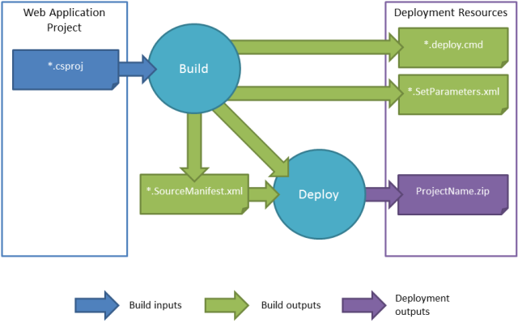

Fig A.1 Compiler and Interpreter

**How do web applications work?**

The figure below details the three-layered web application model. The first layer is normally a web browser or the user interface; the second layer is the dynamic content generation technology tool such as Java servlets (JSP) or Active Server Pages (ASP), and the third layer is the database containing content (e.g., news) and customer data (e.g., usernames and passwords, social security numbers and credit card details).

[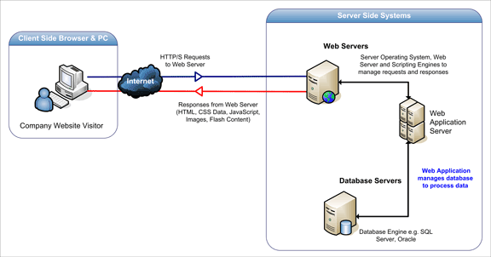](http://www.acunetix.com/wp-content/uploads/2012/10/web-apps.gif)

Fig A.2 Three-Layered Web Application Model

The figure below shows how the initial request is triggered by the user through the browser over the Internet to the web application server. The web application accesses the databases servers to perform the requested task updating and retrieving the information lying within the database. The web application then presents the information to the user through the browser.



Fig A.3 Client’s Request and Response.

**Page Controller Pattern in ASP.NET**

Each page has a code-behind class, and the URL requested by the client is directly handled by individual pages. Any button or server control causing post backs (such as a Drop down List control) is handled directly by the page code-behind class. So understanding the page life cycle is very important in a page controller based architecture. Here is a diagram that shows how a page controller pattern works in ASP.NET:



Fig A.4 Page Controller in ASP.NET.

**A.3 MVC**

MVC, which stands for Model View Controller, is a design pattern that helps us to achieve the decoupling of data access and business logic from the presentation code ,and also gives us the opportunity to unit test the GUI effectively and neatly, without worrying about GUI changes at all.

MVC design has three major parts:

* **Model:** This refers to the data that is shown in the UI. This data can come

From different sources, for example, a database.

* **View:** This refers to the user interface (UI) components that will show the

Model data.

* **Controller:** This controls when to change the view, based on user actions,

Such as button clicks.

**ASP.NET MVC CONTROLLER**

In terms of ASP.NET web applications, the model, view, and controller participants can be identified as:

**View:** This refers to HTML mark-up in ASPX pages, minus the code-behind logic. This view is rendered in the presentation tier (the browser).

**Controller:** This refers to the special controller classes that decide which Model needs to be shown to which particular view.

**Model:** This refers to the data coming from the data layer, which may be processed by the business layer.

In the MVC design, the model, the view, and the controller are not related directly to the layers, or to the physical tiers; they are logical components that operate together in a certain pattern. The controller is related directly to the model and the view.

Based on user actions (in the view), it fetches the data (the model) and populates the view. The relationship between the controller, the model, and the view can be depicted as:



Fig A.5 Relationship between controller, model and view

**A.4 VISUAL STUDIO 2010 ENVIRONMENT**

Visual Studio 2010 (VS) is an integrated development environment (IDE); a set of tools in a single application that helps you write programs. Without VS, you would need to open a text editor, write all of the code, and then run a command-line compiler to create an executable application.

The issue with the text editor and command-line compiler is that you would lose a lot of productivity through manual processes. Fortunately, you have VS to automate many of the mundane tasks that are required to develop applications. The following sections explain what VS will do for you and why VS is all about developer productivity. It offers the following features such as

### Better code intelligence

1. Simplify development
2. Build a better application faster
3. Customize using extensions
4. Quickly add user-friendly features
5. Speed Deployment and Updates
6. Create a custom application for the way you do business
7. Build business applications like they were created by a professional designer
8. Easily add powerful authentication features
9. Evolves the application as business needs change

**A.5 VISUAL BASIC**

Visual Basic is a tool that allows you to develop Windows (Graphic User Interface - GUI) applications. The applications have a familiar appearance to the user.

Visual Basic is event-driven; meaning code remains idle until called up onto respond to some event (button pressing, menu selection,). An event processor governs Visual Basic. Nothing happens until an event is detected. Once an event is detected, the code corresponding to that event (event procedure) is executed. Program control is then returned to the event processor.



Fig A.6 Event Handling in Visual Basic

**FEATURE OF VISUAL BASIC**

Some of the key Features of visual Basic are

* Faster compiler
* ActiveX data control object
* Allows database integration with wide variety of applications
* Data report designer
* Package & Deployment Wizard
* Additional internet capabilities

**A.6 JAVA SCRIPT**

JavaScript is the world's most popular programming language. It is the language for HTML and the web, for servers, PCs, laptops, tablets, smart phones, and more. JavaScript is a Scripting Language produced by Netscape for use within HTML Web pages.

JavaScript is loosely based on Java and it is built into all the major modern browsers. JavaScript is a prototype-based scripting language that is dynamic, weakly typed, and has first-class functions. Its syntax was influenced by the language C.

**FEATURES**

* JavaScript is a lightweight, interpreted programming language
* Designed for creating network-centric applications
* Complementary to and integrated with Java
* Complementary to and integrated with HTML
* Open and cross-platform

**JAVASCRIPT SYNTAX**

A JavaScript consists of JavaScript statements that are placed within the <script>... </script> HTML tags in a web page. You can place the <script> tag containing your JavaScript anywhere within you web page but it is preferred way to keep it within the <head> tags.

The <script> tag alerts the browser program to begin interpreting all the text between these tags as a script. So simple syntax of your JavaScript will be as follows



Fig A.7 JavaScript Syntax

The script tag takes two important attributes:

* **LANGUAGE:** This attribute specifies what scripting language you are using. Typically, its value will be JavaScript. Although recent versions of HTML (and XHTML, its successor) have phased out the use of this attribute.
* **TYPE:** This attribute is what is now recommended to indicate the scripting language in use and its value should be set to *"*text/JavaScript*".*

So your JavaScript segment will look like:



Fig A.8 JavaScript Segment

**A.7 CASCADING STYLE SHEET:**

Cascading style sheets are used to format the layout of Web pages. They can be used to define text styles, table sizes, and other aspects of Web pages that previously could only be defined in a page's HTML.

CSS helps Web developers create a uniform look across several pages of a Web site. Instead of defining the style of each table and each block of text within a page's HTML, commonly used styles need to be defined only once in a CSS document.

The Cascading Style Sheets Specification (CSS) is a computer language that is used to write formatting instructions (rules).

These rules tell a web browser how webpage content should ‘look’— in terms of:

* layout
* Position, alignment, width, height, etc.
* style
* Typeface, font-weight, color, border, etc.

As an example, all level-one headings can be set in the typeface Verdana and coloured red with the rule:

**EXAMPLE**

h1 {

font-family: Verdana;

color: red; }

Fig A.9 Sample CSS Code

The CSS language was created to meet the aesthetic demands placed on HTML: the computer language used to author WebPages.

The CSS language specification(s) set out how rules can be written and should be implemented by web browser developers.

**The benefits of CSS**

* Separation of content and presentation
* CSS rules can be provided in a file that is separate to the (content) HTML. If all pages link to this centralized CSS file, then the look of a website can more easily be updated. For example, the color or size of all level-one headings can be changed by updating a single CSS rule

**A.8 MS ACCESS DATABASE**

Microsoft Office Access provides a highly integrated set of tools that can be used together to create tables for data storage, links to external data sources, queries for retrieving and manipulating data, forms for data entry, reports for aggregating and analyzing data, macros to automate common tasks, and Microsoft Visual Basic® for Applications (VBA) code for creating advanced Customizations. The following sections give an overview of how these Access objects enable users to meet their business requirements, and how Microsoft is enhancing these objects for Office Access 2007



Fig A.10 MS Access 2007.

**TABLE CREATION**

Office Access 2007 will make the creation of native Access tables more intuitive, especially for users who are familiar with Excel. In fact, users will be able to copy and paste a range of cells from Excel into Access and have the table schema inferred automatically. Office Access 2007 will also enhance the grid-like datasheet view with new filtering, sorting, and totaling features.



Fig A.11 MS-Access Table Data view.

# A.9 MICROSOFT AJAX

AJAX stands for Asynchronous JavaScript and XML. Each of these composite pieces has an impact on the network, for varying reasons.

Microsoft Ajax features enable you to quickly create Web pages that provide a rich user experience and that include responsive and familiar user interface (UI) elements. By using Microsoft Ajax, you can improve the user experience and the efficiency of your Web applications.

Microsoft Ajax applications are compatible with all popular modern Web browsers, including Microsoft Internet Explorer, Mozilla Firefox, and Google Chrome.

**ASYNCHRONOUS LOADING USING AJAX**

The sender (client) and receiver (server) aren't taking turns anymore. While traditional browser-based applications, primarily enabled through form submission, follow the request-reply paradigm just like its underlying transport (HTTP), AJAX-based applications do not. Both the browser and the client can be doing things independent of one another. While the user is interacting with the UI, the browser can be pre-fetching images and validating data at the same time.

* **Impact on the client: More requests.** A good example of this is Google Maps. While you’re looking at the first snippet of the map presented, the client is quietly retrieving other large chunks of image data under the covers. This is what makes panning and zooming around in Google Maps appear so seamless—the data was loaded behind your back, whether you wanted it or not.
* **Impact on the communication path: More data**, it's smaller data in general, but there's actually more—it's just spread out across many more requests, which increases the overall traffic on the wire.
* **Impact on the server: More responses**. The server has to reply to the additional requests and serve up the additional data whether the user will view it or not. There are also connection issues, as real-time functionality requires a nearly constant stream of data flowing between the client and the server, using up resources on the server.

**APPENDIX B**

**SAMPLE CODING**

**DEFAULT.ASPX.VB**

Imports System.Data.OleDb

Imports System.Data

Imports System.Data.SqlClient

Imports System.Net.WebRequestMethods

Partial Class _Default

Inherits System.Web.UI.Page

Dim provider As String

Dim dataFile As String

Dim connString As String

Dim myConnection As OleDbConnection = New OleDbConnection

Dim drAsOleDbDataReader

Dim cmd As OleDbCommand

Public count As Integer

Dim str As String

Dim b As Integer

Dim idd As String = ""

Public topic As String

Public maxvalue As Integer

Public arr(100) As Integer

Public pasvar As Integer

Protected Sub Page_Init(ByVal sender As Object, ByVal e As System.EventArgs) Handles Me.Init

Dim clue As String = ""

Label1.Visible = False

Try

topic = Request.Cookies("topic").Value

count = Request.Cookies("rescook").Value

Catch ex As Exception

MsgBox("this is summa error")

End Try

Try

provider = "Provider=Microsoft.ACE.OLEDB.12.0;Data Source ="

dataFile = Server.MapPath("db/th.accdb")

connString = provider &dataFile

myConnection.ConnectionString = connString

myConnection.Open()

Dim str As String

str = "SELECT * FROM " & topic & " where ID= " &arr(count)

Dim cmd As OleDbCommand = New OleDbCommand(str, myConnection)

dr = cmd.ExecuteReader

While dr.Read()

pasvar = dr.GetInt32(0)

clue = dr.GetString(2)

End While

If clue = " " Then

count = count + 1

MsgBox("LUCKY USER ADVANCED TO NEXT LEVEL")

Response.Cookies("rescook").Value = count

Response.Redirect("Default.aspx")

End If

dr.Close()

myConnection.Close()

Catch ex As Exception

MsgBox("exception was handled in default page")

End Try

If topic = "monuments" Then

Dim NewImage As Image = New Image()

NewImage.ImageUrl = ("~/images/monuments/" & clue)

NewImage.Visible = True

NewImage.AlternateText() = "unable to load"

ques.Controls.Add(NewImage)

Label1.Visible = True

mystyle1.Visible = False

Else

ques.InnerText = " " + clue

End If

Response.Cookies("rescook1").Value = pasvar

End Sub

Protected Sub Button1_Click(ByVal sender As Object, ByVal e As System.EventArgs) Handles Button1.Click

Response.Redirect("map.aspx")

End Sub

Protected Sub Page_PreInit(ByVal sender As Object, ByVal e As System.EventArgs) Handles Me.PreInit

arr = Page.Session("myarray")

End Sub

End Class

**MAP.ASPX.VB**

Imports System.Data.OleDb

Imports System.Data

Imports System.Data.SqlClient

Imports System.Net.WebRequestMethods

Partial Class map

Inherits System.Web.UI.Page

Dim provider As String

Dim dataFile As String

Dim connString As String

Dim myConnection As OleDbConnection = New OleDbConnection

Dim drAsOleDbDataReader

Dim cmd As OleDbCommand

Public str As String

Public place As String = ""

Public clue As String = ""

Public hint1 As String = ""

Public hint2 As String = ""

Public hint3 As String = ""

Public lat1 As String = ""

Public lat2 As String = ""

Public zz As String = ""

Dim count As Integer

Public tt As Integer

Dim topic As String = ""

Protected Sub Page_Load(ByVal sender As Object, ByVal e As System.EventArgs) Handles Me.Load

Try

topic = Request.Cookies("topic").Value

count = Request.Cookies("rescook1").Value

Catch ex As Exception

MsgBox("this is summa error")

End Try

Try

provider = "Provider=Microsoft.ACE.OLEDB.12.0;Data Source ="

dataFile = Server.MapPath("db/th.accdb")

connString = provider &dataFile

myConnection.ConnectionString = connString

myConnection.Open()

Dim str As String

str = "SELECT * FROM " & topic & " where ID= " & count

Dim cmd As OleDbCommand = New OleDbCommand(str, myConnection)

dr = cmd.ExecuteReader

While dr.Read()

place = dr.GetString(1)

clue = dr.GetString(2)

hint1 = dr.GetString(3)

hint2 = dr.GetString(4)

hint3 = dr.GetString(5)

lat1 = dr.GetString(6)

lat2 = dr.GetString(7)

zz = dr.GetInt32(8)

End While

dr.Close()

myConnection.Close()

If topic = "monuments" Then

ques.InnerHtml = "SPOT THE MONUMENTS"

Else

ques.InnerText = clue

End If

Catch ex As Exception

MsgBox("exception was handled in map page" + ex.ToString)

End Try

End Sub

End Class

**SCORE.ASPX.VB**

Partial Class score

Inherits System.Web.UI.Page

Public count As Integer

Public topic As String = ""

Public total As Integer

Protected Sub Page_Load(ByVal sender As Object, ByVal e As System.EventArgs) Handles Me.Load

topic = Request.Cookies("topic").Value

count = Request.Cookies("rescook").Value

total = Request.Cookies("total").Value

End Sub

Protected Sub Button1_Click(ByVal sender As Object, ByVal e As System.EventArgs) Handles Button1.Click

If topic = "continents" Then

If count < 5 Then

count = count + 1

Response.Cookies("rescook").Value = count

Response.Redirect("Default.aspx")

Else

Response.Redirect("complete.aspx")

End If

ElseIf topic = "countries" Then

If count < 8 Then

count = count + 1

Response.Cookies("rescook").Value = count

Response.Redirect("Default.aspx")

Else

Response.Redirect("complete.aspx")

End If

ElseIf topic = "cities" Then

If count < 8 Then

count = count + 1

Response.Cookies("rescook").Value = count

Response.Redirect("Default.aspx")

Else

Response.Redirect("complete.aspx")

End If

ElseIf topic = "capitals" Then

If count < 8 Then

count = count + 1

Response.Cookies("rescook").Value = count

Response.Redirect("Default.aspx")

Else

Response.Redirect("complete.aspx")

End If

Else If topic = "monuments" Then

If count < 8 Then

count = count + 1

Response. Cookies("rescook").Value = count

Response. Redirect("Default.aspx")

Else

Response.Redirect("complete.aspx")

End If

End If

End Sub

End Class

**APPENDIX C**

**SAMPLE SCREEN SHOTS**

**HOME PAGE**

C:\Documents and Settings\ponmani\Desktop\screen shots\Untitled-1.tif

Fig C. 1 Output screen of Home page

This snapshot display the home page where the gamer can select the various modes.

**LEVEL PAGE**

**C:\Documents and Settings\ponmani\Desktop\screen shots\level.tif**

Fig C. 2 Output screen of Level page

This snapshot displays the list of level that allows the user to select one of the levels and start the hunting mode.

**QUESION PAGE**

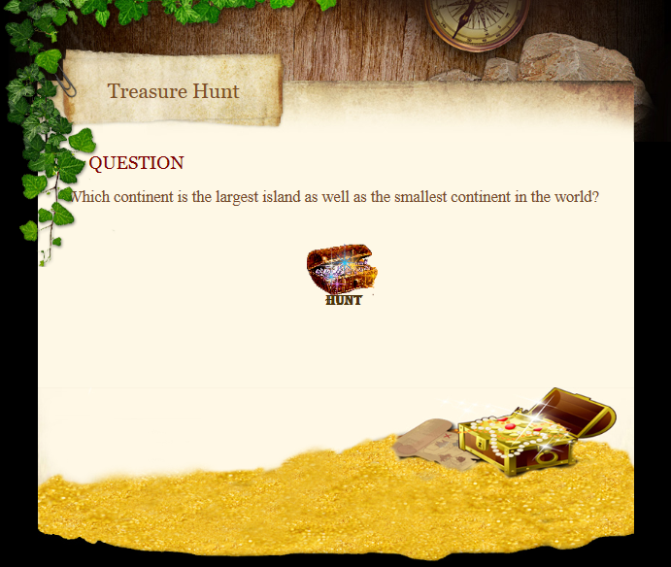

Fig C. 3 Output screen of Question page

This snapshot display the question page, in which the user is set to view the question and then begin hunting by pressing the “HUNT” button.

**MAP PAGE**

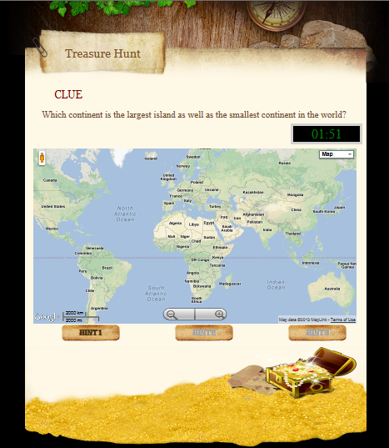

Fig C. 4 Output screen of Map page

This snapshot displays the map which is to be hunt for the specified Question. The Hunt begins by zooming the place referred in the question.

**HINTS**

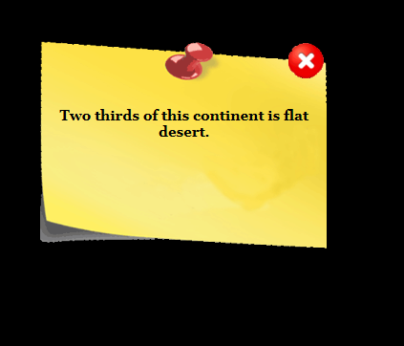

Fig C. 5 Output screen of Hint Window

This snapshot contains the Hint window which is display for the gamer on demand. The usages of hint will result in penalty, which reduce the score obtained.

**FINDING THE MARKER**

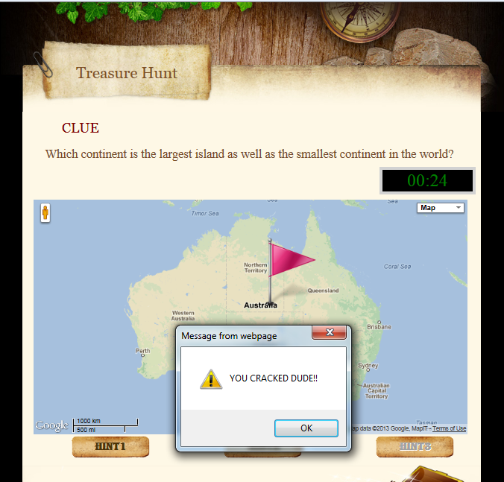

Fig C. 6 Output screen of Marker

This snapshot displays the marker which indicates the specified place. By clicking the marker, will redirect the gamer to the score page.

**TIME OVER**

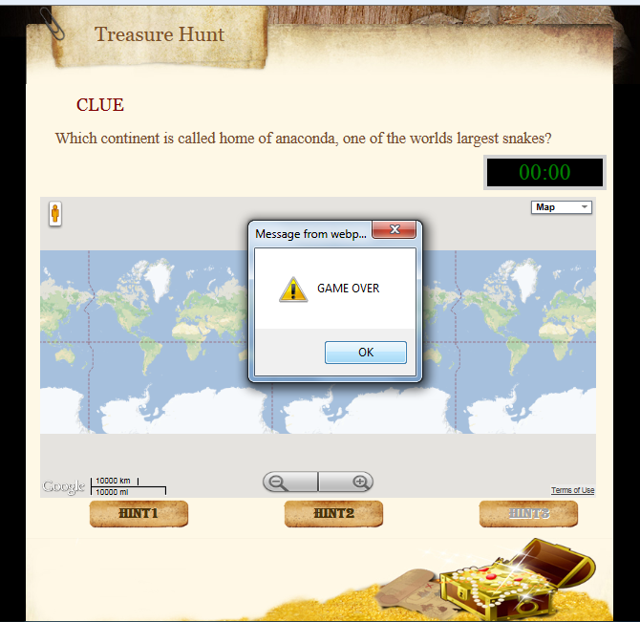

Fig C. 7 Output screen of Time over

This snapshot displays the time over window. If the gamer is not able to find the specified place within the stipulated time then the game over will triggered.

**GAME OVER**

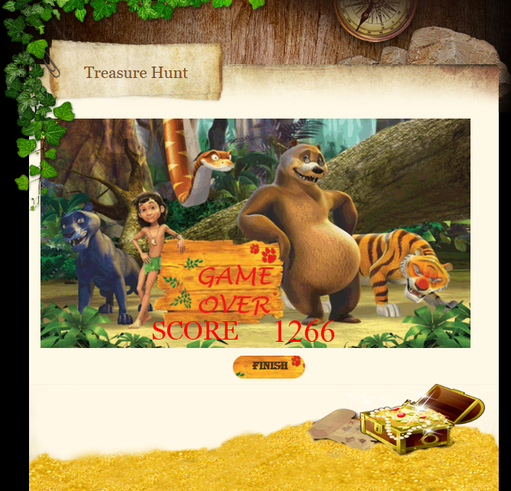

Fig C. 8 Output screen of Game over page

This snapshot display the Game over page. This page is enabled only if the user is unable to find the given place within the allotted time.

**EDIT PAGE**

**C:\Documents and Settings\ponmani\Desktop\screen shots\edit page.tif**

Fig C. 9 Output screen of Edit page

This snapshots display the edit page, in which the admin can add information to the database. The admin can also update or delete the information from the database.

**ROAMING MODE**

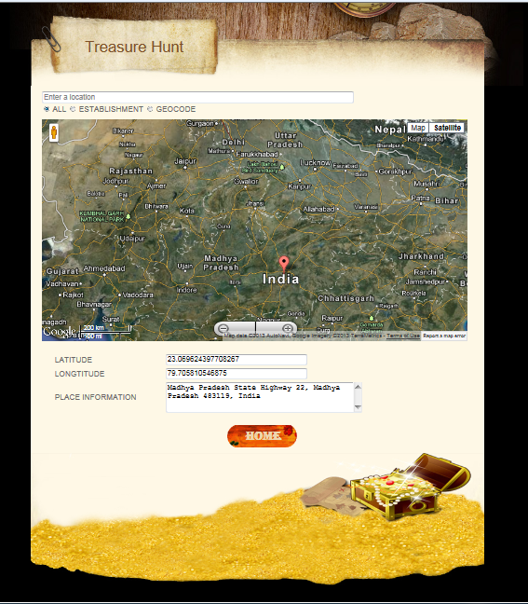

Fig C. 10 Output screen of Roaming page

This snapshot displays the roaming mode, where the gamer can search for the information about place. It also enables the gamer to obtain the latitude, longitude and place name of specified place.

**INTRUCTION PAGE**

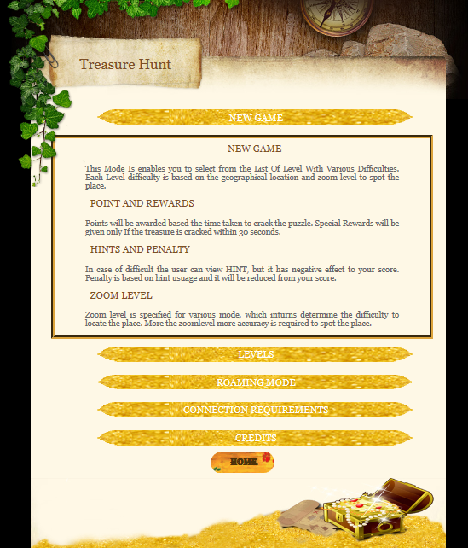

Fig C. 11 Output screen of Instruction page

This snapshot displays the Instruction page, which allow new gamer to know about and game. It displays the rules and guide lines for the game.

**HIGH SCORE**

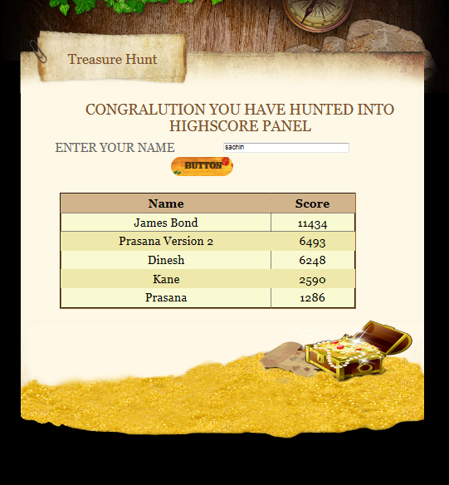

Fig C. 12 Output screen of High score page

This snapshot display high score page. It display the top five score of the gamers who emerged as top scorers of various level.

**REFERENCES**

[1] Matthew Macdonald, ASP.NET: The Complete Reference books**,** 2002 Edition.

[2]Jeffrey C. Jackson, "Web Technologies--A Computer Science Perspective", Pearson Education, 2006.

### [3] David Flanagan, The Definitive Guide, O'Reilly Media publisher, 5th Edition, 2006 Edition.

### [4] Christopher Schmitt, CSS Cookbook, O'Reilly Media publisher, 3rd Edition, 2009 Edition.

[5] Seth Ladd, Darren Davision, Steven Devijver and Colin Yates, Apress Expert Spring MVC and Web Flow, First Edition.

[6] http://www.dotnetcurry.com/ShowArticle.aspx?ID=329 (Referred on 20.02.2013,17.03.2013 )

[7] http://www.asp.net/ (Referred on 05.01.2013, 08.02.2013 )

[8] http://www.w3schools.com/aspnet (Referred on 16.02.2013, 29.02.2013 )

[9]https://developer.mozilla.org/en-US/docs/JavaScript (Referred on 12.01.2013, 28.02.2013 )

[10] www.stackoverflow.com (Referred on 09.01.2013, 15.03.2013 )